**AIM -->**

To design a system for car stereo systems such that whenever the increase volume button is pressed, a Green Light is emitted for 20 milliseconds & whenever the decrease volume button is pressed, a Red Light is emitted for 40 milliseconds.

**CIRCUIT DIAGRAM=**

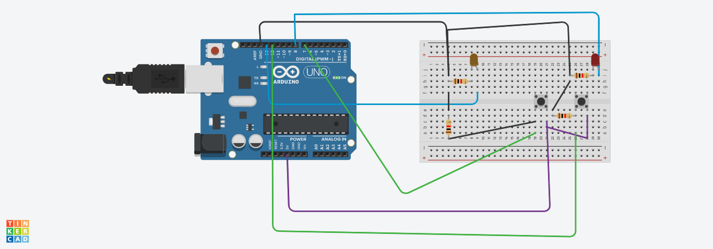

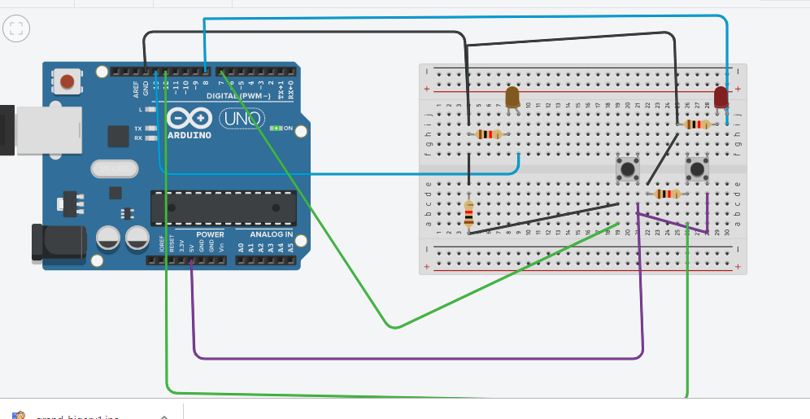

**VOLUME DOWN**

**VOLUME UP**

**THEORY=**

***Arduino*** refers to an open-source electronics platform or board and the software used to program it. **Arduino** is designed to make electronics more accessible to artists, designers, hobbyists and ayone interested in creating interact

A **breadboard** is a construction base for prototyping of electronics.

A ***circuit*** is a closed path that allows electricity to flow from one point to another. It may include various electrical components, such as [transistors](https://techterms.com/definition/transistor), resistors, and capacitors, but the flow is unimpeded by a gap or break in the circuit.

***Kirchhoff's Current Law (KCL)*** is Kirchhoff's first law that deals with the conservation of charge entering and leaving a junction. ... His current law states that for a parallel path the total current entering a circuits junction is exactly equal to the total current leaving the same junction.

A ***loop*** is a programming structure that repeats a sequence of instructions until a specific condition is met. Programmers use loops to cycle through values, add sums of numbers, repeat [functions](https://techterms.com/definition/function), and many other things.

**LEARNING AND OBSERVATION=**

Whenever the increase volume button is pressed , a Green Light is emitted for 20 milliseconds & whenever the decrease volume button is pressed, a Red Light is emitted for 40 milliseconds.

Learned about ***loops*** and ***Arduino***. Circuit set up is also clear.

**PROBLEM AND TROUBLESHOOTING=**

1. Setting up a connection.
2. Errors in code.
3. Port was not selected.
4. Proper Power supply

**PRECAUTIONS=**

1. Don't plug **in** an LED without a current limiting resistor.
2. Don't supply it with more then 9V.
3. Circuit must be correct.
4. proper terminal should be connected in proper pinmode according to code

**LEARNING OUTCOMES=**

1. Learned programming concepts using C along with Arduino specific programming.
2. Usage of a wide variety of hardware and components and prototype your projects using a breadboard.
3. Understand what an Arduino is and how it work and learnt how to use an Arduino safely.

## Programming:

int buttonState1 = 0; \\for volume up

int buttonState2 = 0; \\for volume down

void setup()

{

pinMode(13,OUTPUT);

pinMode(7,INPUT);

}

void loop()

{

buttonState1 = digitalRead(7);

if(buttonState1 == HIGH)

{

digitalWrite(13, HIGH);

delay(20);

digitalWrite(13, LOW);

}

else

{

digitalWrite(13 , LOW);

}

buttonState2 = digitalRead(12);

if(buttonState2 == HIGH)

{

digitalWrite(8, HIGH);

delay(40);

digitalWrite(8,LOW);

}

else

{

digitalWrite(8, LOW);

}

}